**Final Project Report**

**NLP Chatbot Development Using Dialogflow**



**Project Supervisor**

Abdullah Qamar

**Submitted By**

F24PROJECTA15B3

Ilsa BC210203055

**Software Projects & Research Section,**

**Department of Computer Sciences,**

**Virtual University of Pakistan**

|  |
| --- |
|  |



**CERTIFICATE**

This is to certify that Ilsa (BC210203055) have worked on and completed their Software Project at Software & Research Projects Section, Department of Computer Sciences, Virtual University of Pakistan in partial fulfillment of the requirement for the degree of BS in Computer Sciences under my guidance and supervision.

In our opinion, it is satisfactory and up to the mark and therefore fulfills the requirements of BS in Computer Sciences.

**Supervisor / Internal Examiner**

Abdullah Qamar

Supervisor,

Software Projects & Research Section,

Department of Computer Sciences

Virtual University of Pakistan

___________________

(Signature)

**External Examiner/Subject Specialist**

<<External Supervisor Name>>

___________________

(Signature)

**Accepted By:**

**_____________**

(For office use)

**EXORDIUM**

**In the name of Allah, the Compassionate, the Merciful.**

**Praise be to Allah, Lord of Creation,**

**The Compassionate, the Merciful,**

**King of Judgment-day!**

**You alone we worship, and to You alone we pray for help,**

**Guide us to the straight path**

**The path of those who You have favored,**

**Not of those who have incurred Your wrath,**

**Nor of those who have gone astray.**

**DEDICATION**

This project is dedicated to the spirit of knowledge and innovation that has fueled our academic journey. I extend my heartfelt gratitude to our mentors and educators whose guidance has been the compass navigating us through the sea of learning. Special thanks to my family and friends for their unwavering support and understanding during the highs and lows of this endeavor. This project stands as a testament to the collective effort and determination of a dedicated team. May it inspire future students to embark on their own quests for knowledge and discovery.

*With gratitude,*

***Ilsa***

**ACKNOWLEDGEMENT**

I express my sincere gratitude to *Virtual University of Pakistan* for providing us with the platform and resources to undertake this project. My deepest appreciation goes to my project supervisor, ***Mr. Abdullah Qamar***, for their invaluable guidance, support, and insightful feedback that significantly contributed to the refinement of my work.

I extend my thanks to the faculty and staff members of the department of Computer Science for fostering an environment of academic excellence. Special thanks to our friends and peers for their collaborative spirit and encouragement throughout this academic endeavor.

My heartfelt appreciation is reserved for my family, whose unwavering support and understanding were the bedrock of my journey. Their encouragement fueled my determination, and I am truly grateful for the sacrifices they made to see me succeed.

Lastly, I acknowledge the research community and the pioneers in the field whose work served as a beacon of inspiration for my project.

*Thank you,*

***Ilsa***

**PREFACE**

This report presents the final year project titled *"****NLP Chatbot Development using Dialogflow****"* developed as part of my undergraduate studies. The aim of this project was to design and implement a conversational agent capable of assisting users with common pharmacy-related queries using natural language processing (NLP) techniques.

The growing use of chatbots in healthcare inspired this project, particularly in pharmacy settings where quick, reliable access to information can enhance customer service and operational efficiency. The chatbot was developed to answer frequently asked questions, provide medication-related information, and simulate basic interaction through a rule-based approach. The system uses keyword recognition, intent matching, and predefined responses to manage user interactions.

This report documents the process from initial requirement gathering to final implementation. It includes the project planning, design methodologies, use case analysis, system architecture, user interface development, and testing phases. The experience offered valuable insight into applying NLP in a practical, domain-specific application.

I would like to express my sincere gratitude to my supervisor and faculty members for their continued support and guidance throughout this project. Their feedback played a vital role in shaping the final outcome.

I hope this work contributes meaningfully to the growing interest in conversational systems within healthcare and serves as a foundation for future developments in pharmacy-focused digital assistance.

**TABLE OF CONTENTS**

|  |
| --- |
|  |

CHAPTER NO. 1

gathering & Analyzing info 10

1.1 Introduction

1.2 purpose

1.3 scope

1.4 definitions, acronyms and abbreviations

1.5 use cases and usage scenarios

1.5.1 Use Case Diagrams

1.5.2 Usage Scenarios

1.6 supplementary requirements

1.6.1 Usability

1.6.2 Reliability

1.6.3 Supportability

1.6.4 System Requirements

CHAPTER NO. 2

planning the project 17

2.1 Introduction

2.2 Methodology

* 1. Available Methodologies
  2. Chosen Methodology
  3. Reasons for Chosen Methodology
  4. Work Plan
  5. Project Structure
     1. Team Structure
     2. Project Schedule (Submission Calendar)

CHAPTER NO. 3

designing PROJECT 22

3.1 Introduction

3.2 purpose

3.3 scope

* 1. definitions, acronyms and abbreviations
  2. Dynamic Model: Sequence Diagrams
  3. Object Model/Logical Model: Class Diagram
  4. Database Model (Database Diagram)
  5. Graphical User Interfaces

Chapter no.4

DEvelopment 35

4.1 Development plan (Architecture Diagram)

**CHAPTER 1**

Gathering & Analyzing Info

* 1. **INTRODUCTION**

This chapter outlines the initial phase of the project, which involved gathering and analyzing the information necessary to design an effective pharmacy-focused chatbot. It covers the identification of user needs, system goals, use cases, and technical requirements. Through careful analysis of the problem domain and relevant user scenarios, the foundation was laid for developing a chatbot capable of handling pharmacy-related queries with clarity, consistency, and domain relevance.

* 1. **PURPOSE**

The purpose of this project is to develop a domain-specific chatbot that assists users with common pharmacy-related queries using natural language processing. The chatbot is intended to provide timely and accurate responses about medications, prescriptions, and general pharmacy services, thereby improving user experience and reducing the burden on human staff. It is designed as a rule-based system to ensure reliability, ease of customization, and straightforward deployment in real-world pharmacy environments.

**1.3 SCOPE**

The scope of this project is to develop an AI-powered chatbot using Google Dialogflow tailored for a pharmacy store. The chatbot will automate customer service tasks, providing customers with information on product availability, recommending over-the-counter products, managing medicine reminders, and offering delivery options. The primary goal is to enhance customer interaction, improve operational efficiency, and support customer health by aiding medication adherence.

**Project Overview:**

1. This chatbot will act as a virtual assistant, available 24/7, to assist pharmacy customers.
2. It aims to address common customer needs, minimize wait times, and provide a seamless, conversational interface for the pharmacy's digital services.
3. A secure and reliable user authentication to access the platform by securing login credentials.

**Constraints:**

The chatbot will:

* Provide information about product availability.
* Offer general product recommendations.
* Allow customers to set medication reminders.
* Accept and process home delivery requests.
* The address frequently asked questions about store operations

The chatbot will not:

* Diagnose or prescribe medication.
* Process payment transactions for purchases.
* Replace pharmacists for complex queries that require professional advice.

**1.4 DEFINITIONS, ACRONYMS AND ABBREVIATIONS**

**Definitions**:

* **Natural Language Processing (NLP)**: A branch of artificial intelligence that enables computers to understand, interpret, and generate human language.
* **Chatbot**: A software application designed to simulate human-like conversation through text or voice interfaces, often used for customer support or information delivery.
* **Sequence Diagram**: A type of UML diagram that shows how objects interact in a particular scenario of a use case, focusing on the sequence of messages exchanged over time.
* **Architecture Design Diagram**: A layered diagram that represents the overall structure of the software system, typically including layers such as the Application Layer, Business Logic Layer, and Database Layer.
* **Class Diagram**: A static diagram that models the structure of a system by showing its classes, attributes, operations, and the relationships among objects.
* **Database Design**: The process of defining the structure, storage, and relationships of data within a system, typically represented through an Entity-Relationship Diagram (ERD).
* **Interface Design**: The visual and functional layout of the system’s user interface (GUI), showing how users will interact with the chatbot and access its features.
* **Intent**: The underlying purpose or meaning behind a user’s input, used by the chatbot to determine the appropriate response.
* **Use Case**: A description of how a user interacts with the system to achieve a specific goal, often illustrated through diagrams and scenarios.

**Acronyms and Abbreviations**:

* **NLP**: Natural Language Processing
* **GUI**: Graphical User Interface
* **ERD**: Entity Relationship Diagram
* **FAQ**: Frequently Asked Questions
* **UML**: Unified Modeling Language
* **DB**: Database

**1.5 USECASES AND USAGE SCENARIOS**

**1.5.1 Use Case Diagram**

**1.5.2 Usage Scenarios**

|  |  |
| --- | --- |
| **Use Case Title:** | **Provide Product Information** |
| **Use Case ID** | 1 |
| **Actors** | Customer, Chatbot |
| **Description** | This use case allows customers to obtain detailed information about a specific product. It is designed to provide accurate and relevant details, ensuring a seamless customer experience. |
| **Pre-Conditions** | The product database must be up to date. |
| **Post-Conditions** | The customer is provided with accurate product information. |
| **User Actions** | |
| 1. Customer requests information about a specific product. 2. Chatbot retrieves product details from the database. 3. Chatbot displays the product name, description, price, and availability status. | |
| **Alternative Path** | If the product is not found, the chatbot informs the customer and suggests contacting the pharmacist. |
| **Exceptions** | 1. Database connection error. 2. Product details are missing in the database. |
| **Author** | BC210203055 |

|  |  |
| --- | --- |
| **Use Case Title:** | **Check Product Availability** |
| **Use Case ID** | 2 |
| **Actors** | Customer, Chatbot |
| **Description** | This case helps customers determine if a specific product is currently in stock, streamlining their shopping experience and decision-making. |
| **Pre-Conditions** | The inventory system must have updated stock details. |
| **Post-Conditions** | The customer knows whether the product is in stock. |
| **User Actions** | |
| 1. Customer asks if a specific product is in stock. 2. Chatbot queries about the inventory system. 3. Chatbot informs the customer about the availability status. | |
| **Alternative Path** | If the product is out of stock, the chatbot offers to notify the customer when it becomes available. |
| **Exceptions** | 1. Inventory system is unavailable. 2. Product not listed in the inventory. |
| **Author** | BC210203055 |

|  |  |
| --- | --- |
| **Use Case Title:** | **Accept Home Delivery Requests** |
| **Use Case ID** | 3 |
| **Actors** | Customer, Delivery Personnel |
| **Description** | This use enables customers to request home delivery of products, ensuring convenience and timely delivery services. |
| **Pre-Conditions** | Product must be in stock. |
| **Post-Conditions** | Delivery request is processed and assigned to delivery personnel. |
| **User Actions** | |
| 1. Customer requests home delivery for a product. 2. Chatbot asks for delivery address and product details. 3. Chatbot confirms the order and delivery schedule. 4. Chatbot sends the order details to the delivery system. | |
| **Alternative Path** | If the product is unavailable, the chatbot informs the customer. |
| **Exceptions** | 1. Delivery system unavailable. 2. Invalid delivery address. |
| **Author** | BC210203055 |

|  |  |
| --- | --- |
| **Use Case Title:** | **Order Tracking** |
| **Use Case ID** | 4 |
| **Actors** | Customer, Chatbot |
| **Description** | This use case allows customers to check the current status of their previously placed orders using an Order ID. |
| **Pre-Conditions** | The customer must provide a valid Order ID. |
| **Post-Conditions** | The chatbot displays the current order status (e.g., Pending, Shipped, Delivered). |
| **User Actions** | |
| 1. Customer asks chatbot for order status. 2. Chatbot asks for the Order ID. 3. Customer provides the Order ID. 4. Chatbot fetches the order status and display. | |
| **Alternative Path** | If the Order ID is not found, the chatbot informs the customer that the order doesn't exist. |
| **Exceptions** | 1. Customer enters an invalid or incomplete Order ID. 2. Database connectivity issue while fetching the order status. |
| **Author** | BC210203055 |

|  |  |
| --- | --- |
| **Use Case Title:** | **Cancel Order** |
| **Use Case ID** | 5 |
| **Actors** | Customer, Chatbot |
| **Description** | This use case allows customers to cancel their placed orders (before shipment) through chatbot interaction. |
| **Pre-Conditions** | Order must exist and be in a cancellable state (e.g., not shipped yet). |
| **Post-Conditions** | Order is marked as "Cancelled" and removed from the shipping queue. |
| **User Actions** | |
| 1. Customer requests to cancel an order. 2. Chatbot asks for the Order ID to be canceled. 3. Customer enters the Order ID. 4. Chatbot checks the current status of the order. 5. If eligible, the chatbot updates the order status to "**Cancelled**" and confirms to the user. | |
| **Alternative Path** | If the order has already been shipped, chatbot informs the user that cancellation is not possible. |
| **Exceptions** | 1. Invalid or missing Order ID. 2. Order already delivered or shipped (not cancellable). 3. Error while updating the order status in the database. |
| **Author** | BC210203055 |

|  |  |
| --- | --- |
| **Use Case Title:** | **FAQs** |
| **Use Case ID** | 6 |
| **Actors** | Customer |
| **Description** | This use case provides customers with quick and accurate answers to common queries, improving user satisfaction and reducing response time. |
| **Pre-Conditions** | FAQ database must be populated with relevant questions and answers. |
| **Post-Conditions** | Customer receives accurate information and answers. |
| **User Actions** | |
| 1. Customer selects or asks a frequently asked question (e.g., store hours, delivery policies). 2. Chatbot retrieves the answer from the FAQ database. 3. Chatbot displays the response to the customer. | |
| **Alternative Path** | If the FAQ is not in the database, the chatbot offers to escalate the query. |
| **Exceptions** | FAQ database not accessible. |
| **Author** | BC210203055 |

|  |  |
| --- | --- |
| **Use Case Title:** | **Submit Feedback** |
| **Use Case ID** | 7 |
| **Actors** | Customer, Chatbot |
| **Description** | This use case allows customers to share feedback about their order experience, helping improve service quality. |
| **Pre-Conditions** | The customer must have placed at least one order. |
| **Post-Conditions** | Feedback is saved and made available to the admin for review. |
| **User Actions** | |
| 1. Customer initiates feedback submission via chatbot. 2. Chatbot prompts the customer to enter their feedback. 3. Customer types and submit their feedback. 4. Chatbot stores the feedback in the system and confirms submission. | |
| **Alternative Path** | If the customer cancels before submitting, the feedback session ends without saving. |
| **Exceptions** | 1. Feedback text is empty. 2. Database error while saving feedback. |
| **Author** | BC210203055 |

**1.6 SUPLEMENTARY REQUIREMENTS**

**1.6.1 Usability**

The chatbot system should be easy to use and intuitive for users with no technical background. The graphical user interface must be clean and simple, providing clear instructions for user interaction. Responses should be prompt, relevant, and phrased in natural, easy-to-understand language. The system should require minimal input to generate accurate responses, and it must be accessible across common web browsers or platforms.

**1.6.2 Reliability**The system should respond consistently and accurately to user inputs, within its defined scope of pharmacy-related queries. It must handle invalid or unexpected inputs gracefully by providing meaningful fallback responses. The chatbot should remain functional under normal operating conditions without frequent crashes or failures. Its rule-based logic should ensure predictability and repeatability in interactions.

**1.6.3 Supportability**  
The chatbot should be easy to maintain and update. Adding new intents, responses, or pharmacy-related information should be possible without significant code restructuring. The architecture should be modular and well-documented, allowing future developers or administrators to modify the system efficiently. Basic logging or error tracking should be in place to help diagnose issues during use.

**1.6.4 System Requirements**

The system should be developed using lightweight, widely supported technologies such as Python and Flask. It should run on any standard operating system that supports these technologies. A basic local server or hosting environment is sufficient for deployment. Minimum hardware requirements include a system with at least 2GB RAM and a modern web browser for accessing the user interface.

**CHAPTER 2**

Planning the Project

**2.1 INTRODUCTION**

This chapter outlines the planning phase of the pharmacy chatbot project, which was crucial in defining the development strategy, selecting appropriate methodologies, and organizing tasks to ensure timely and structured execution. It includes an overview of available development methodologies, justification for the chosen approach, and a breakdown of the project’s work plan and structure. Effective planning provided a clear roadmap for managing resources, setting milestones, and tracking progress throughout the project lifecycle.

**2.2 METHODOLOGY**

Methodology refers to the approach or framework that would be used to guide the development process of the project. It consists of the steps and processes that would be followed to ensure the successful completion of the project. The choice of methodology depends on factors such as project complexity, size and timeline, and stakeholder complexities.

**2.3 AVAILABLE METHODOLOGIES**

There are several methodologies such as:

* Build-and-fix Model
* Waterfall Model
* Rapid Prototyping Model
* Incremental Model
* Extreme Programming
* Object-Oriented Model
* Spiral Model
* Agile Model

**2.4 CHOSEN METHODOLOGY**

The methodology selected for this project is the **VU Process Model**. It integrates the clear, phase-by-phase structure of the Waterfall Model with the iterative feedback and risk management features of the Spiral Model. This combination enables early planning and requirement clarity while allowing iterative refinements based on ongoing evaluation and testing.

The following is the illustration of the phases involved in the **VU process model**: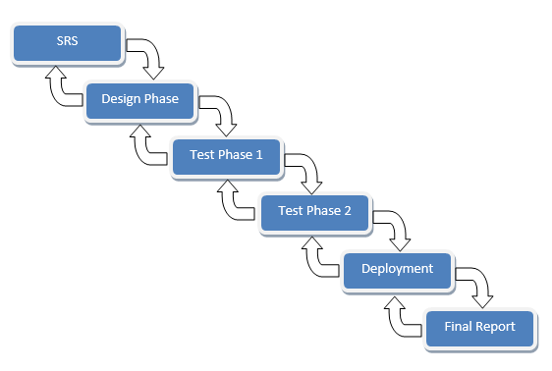

**2.5 REASONS FOR CHOSEN METHODOLOGY**

It derives the benefits of predictability from the milestone-based planning of the waterfall model, as well as the benefits of feedback and creativity from the spiral model.

1. The VU Process Model is documentation driven. This makes it easier to generate complete and up-to-date documentation on each phase of the model, based on the feedback of the client on each development stage.
2. Every phase is dependent on risk analysis and evaluation in this model.
3. It consists of easy progress tracking and risk management.
4. The project can be divided into small units, making it easier to implement the OO approach to develop web-based application.
5. Iterations are easily manageable.
6. Managing Application QA is easy while testing the developed modules individually.

**2.6 WORK PLAN**

### SRS Document: November 13, 2024 – December 4, 2024

### Design Document: 5 December, 2024 – 27 February, 2025

### Prototype Phase Document: 28 February , 2024 – 18 March, 2025

### 

### Final Deliverables: 28 February , 2024 – 18 March, 2025

**2.7 PROJECT STRUCTURE**

* + 1. **Team Structure**

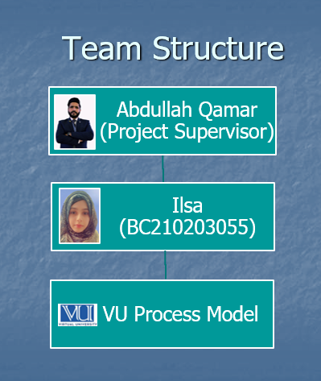

**2.7.2 Project Schedule (Submission Calendar)**

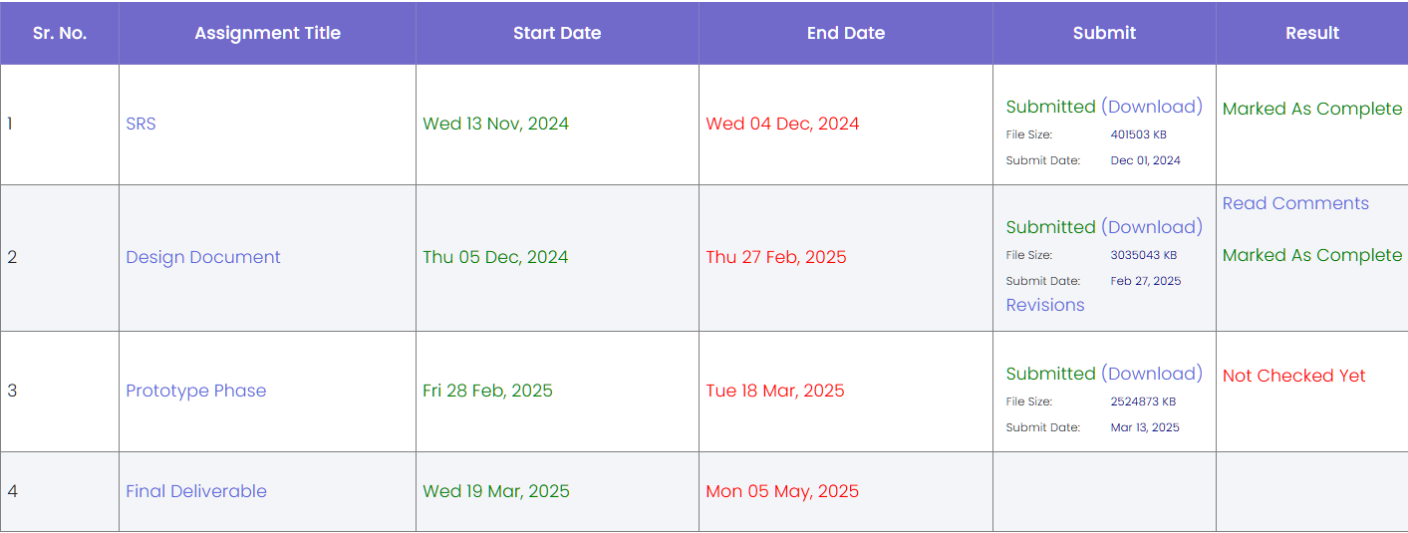

**CHAPTER 3**

Designing the Project

**3.1 INTRODUCTION**

The design phase is a crucial component in the software development life cycle, serving as the foundation upon which the implementation of the NLP-based chatbot is built. This phase translates the system requirements, outlined in the SRS document, into a structured solution that addresses user needs and functional goals. For the "NLP Chatbot Development using Dialogflow" project, the design encapsulates both the architectural and component-level details that will guide developers throughout the implementation process. It includes the creation of dynamic models like sequence diagrams, logical models such as class diagrams, database schema, and the user interface layout. Each of these artifacts contributes to a comprehensive understanding of the system’s behavior, structure, and interaction, thereby ensuring a robust, scalable, and maintainable solution.

**3.2 PURPOSE**

The primary purpose of this design phase is to produce a detailed blueprint of the chatbot system, ensuring that it meets the functional and non-functional requirements defined during the analysis phase. This blueprint acts as a guide for developers and testers to implement and validate the chatbot system effectively. The chatbot is intended to enhance pharmacy customer interactions by automating repetitive tasks, including checking product availability, recommending over-the-counter medications, scheduling medicine reminders, and facilitating delivery services. A well-structured design will help minimize development risks, streamline implementation, and reduce overall project costs by identifying potential issues early in the process.

**3.3 SCOPE**

This design phase encompasses all components necessary for developing the chatbot application using Dialogflow. It includes:

* **Dynamic Modeling:** Sequence diagrams illustrating the flow of interactions for major use cases such as providing product information, setting medication reminders, and accepting delivery requests.
* **Object Modeling:** Class diagrams defining the system’s core components, attributes, operations, and relationships.
* **Database Modeling:** Entity-relationship diagrams detailing how data is stored, retrieved, and related, especially for products, users, orders, and reminders.
* **User Interface Design:** Wireframes and interface mockups that define how users will interact with the system in an intuitive and seamless manner.

The design also considers security, usability, maintainability, and compatibility across multiple platforms and browsers. It does not cover implementation details or low-level programming instructions, which will be addressed in the development phase.

**3.4 DEFINITIONS, ACRONYMS AND ABBREVIATIONS**

* **Class Diagram:** A diagram that illustrates the structure of a system by showing its classes, attributes, methods, and the relationships among objects. It helps in modeling the static structure of the software.
* **Sequence Diagram:** A type of interaction diagram that shows how processes or objects interact in a particular sequence over time, focusing on the order of message exchanges.
* **Entity Relationship Diagram (ERD):** A visual representation used in database design to show the relationships between data entities in a system.
* **Database Schema:** A detailed representation of the database structure, including tables, fields, data types, keys, and constraints.
* **Graphical User Interface (GUI):** The part of the software application that users interact with directly, including buttons, menus, forms, and input fields.
* **Interface Diagram:** A design diagram showing how different modules or systems interact, usually via defined interfaces or APIs.
* **Use Case Diagram:** A UML diagram that represents the functional requirements of the system by illustrating how users (actors) interact with system use cases.
* **Attribute:** A property or characteristic of a class or an entity, such as name, ID, or price.
* **Method:** A function defined within a class that describes the behavior or operations that objects of that class can perform.
* **Entity:** A real-world object or concept represented in a database or system model.
* **Unified Modeling Language (UML):** A standardized language used for modeling the structure and behavior of software systems through diagrams.
  1. **DYNAMIC MODEL:**
     1. **SEQUENCE DIAGRAMS**

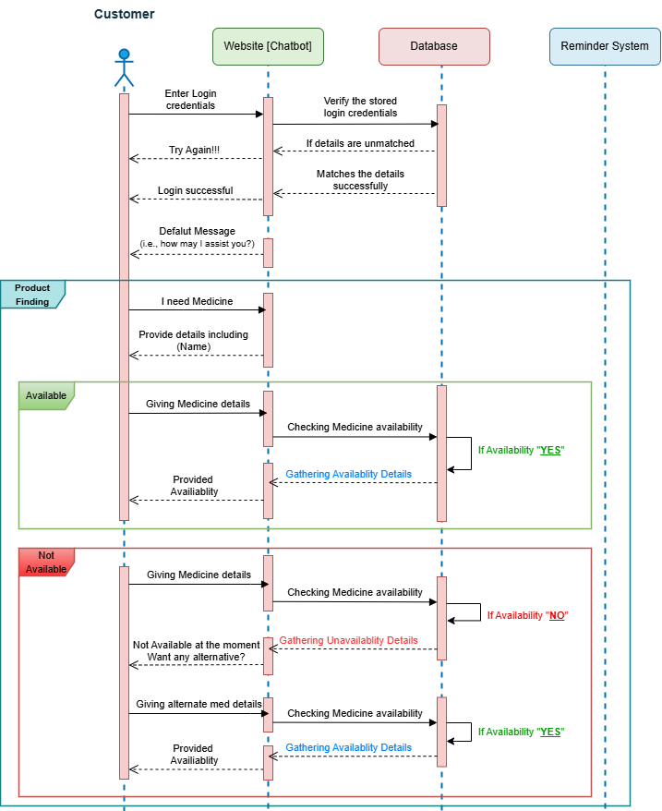

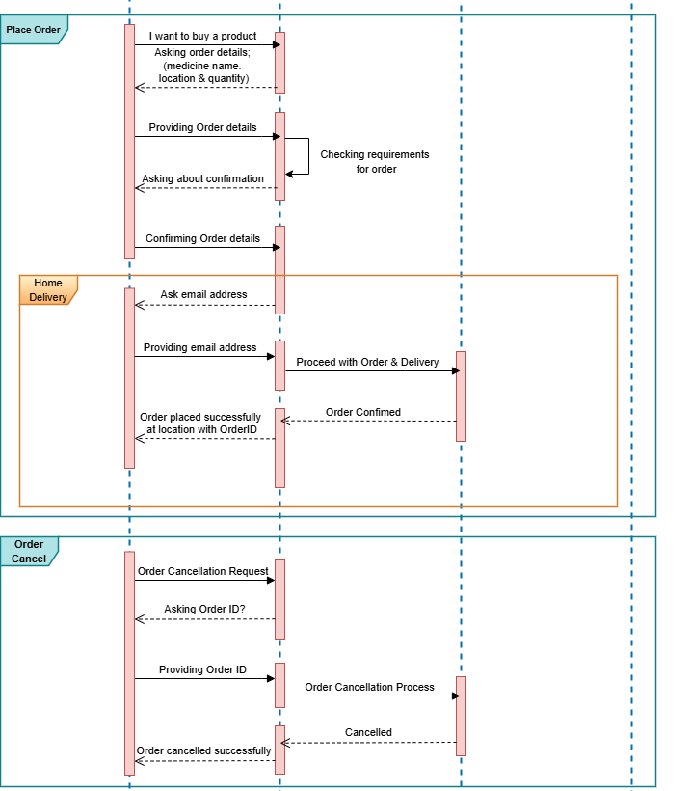



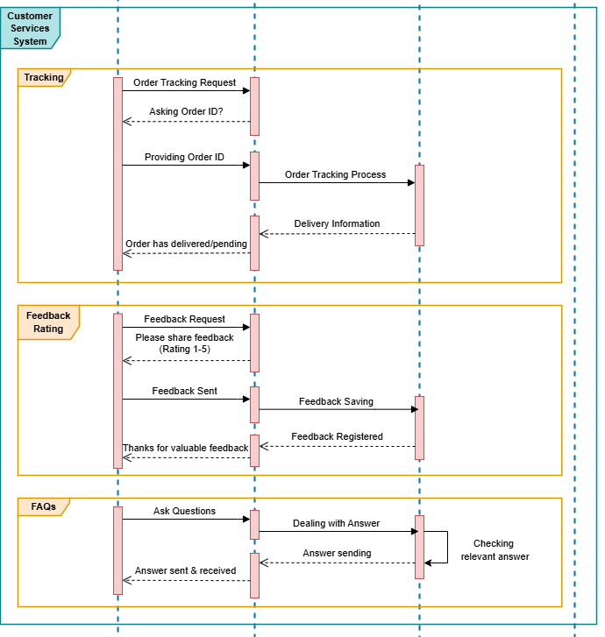

* 1. **OBJECT MODEL/LOGIC MODEL:** 
     1. **CLASS DIAGRAM**

* 1. **DATABASE MODEL:** 
     1. **DATABASE DIAGRAM**

* 1. **GRAPHICAL USER INTERFACES** 
     1. **Home Page**

* + 1. **Sign Up / Registration**

* + 1. **Login**

* + 1. **User dashboard**

* + 1. **Admin dashboard**

* + 1. **Product page**

* + 1. **Product details**

* + 1. **Ordering via Chatbot**

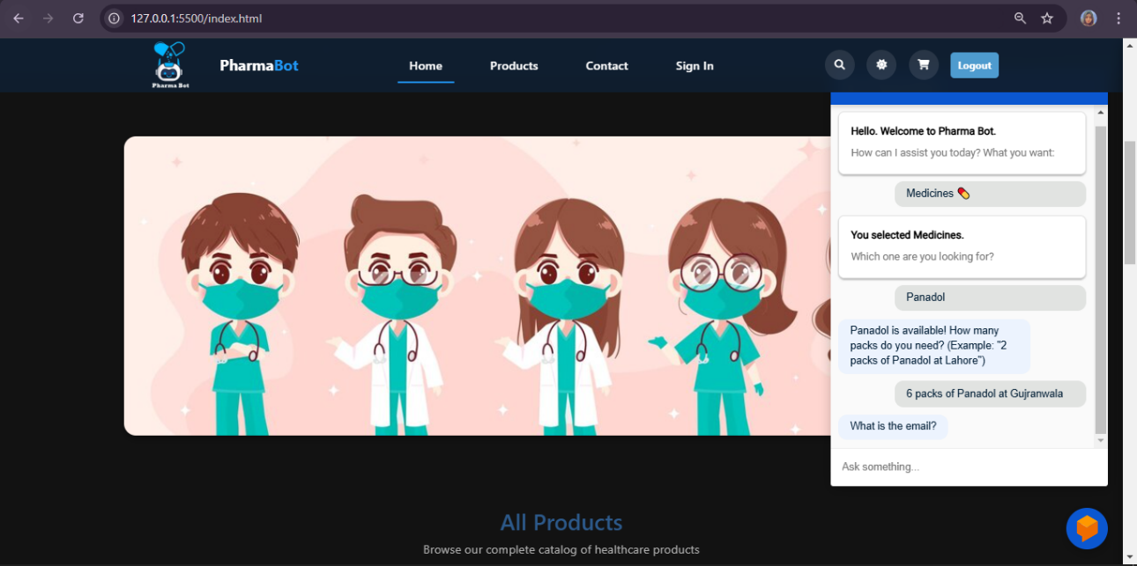

* + 1. **Add to Cart**

* + 1. **Contact us**

**CHAPTER 4**

Development

**4.1 DEVELOPMENT PLAN (ARCHITECTURAL DIAGRAM)**

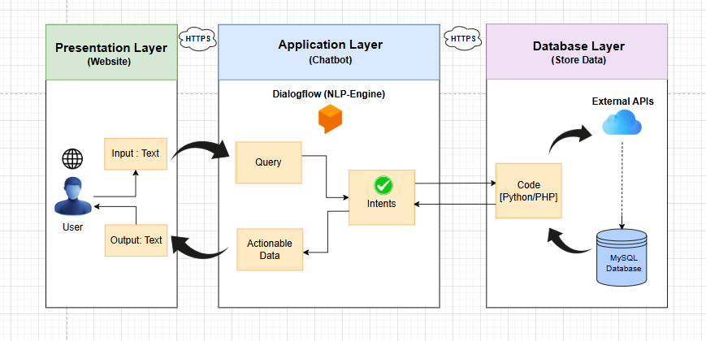

**REFERENCES**

* CS504, Software Engineering – I, Handouts, Virtual University of Pakistan.
* CS605, Software Engineering – II, Handouts, Virtual University of Pakistan.
* CS403, Database Management System, Handouts, Virtual University of Pakistan.
* CS615, Software Project Management, Handouts, Virtual University of Pakistan.
* CS506, Web Design and Development, Handouts, Virtual University of Pakistan
* CS603, Software Architecture and Design, Handouts, Virtual University of Pakistan.
* Dialogflow - (<https://cloud.google.com/dialogflow/docs>)
* MYSQL – (<https://dev.mysql.com/doc/>)
* PHP official documentation - <https://www.php.net/docs.php>
* MDN - <https://developer.mozilla.org/en-US/docs/Web/JavaScript>
* UML Diagrams <https://draw.io/>

**APPENDIX**

|  |  |
| --- | --- |
| **Section** | **Description** |
| **Software Requirements** | Python 3.10, Flask, Dialogflow CX, MySQL, Visual Studio Code, XAMPP |
| **Hardware Requirements** | Minimum 4 GB RAM, modern browser, local server capability |
| **Database Tables** | users, orders, feedback, medicines, prescriptions |
| **Dialogflow Intents** | Order_Medicine, Track_Order_Status, Cancel_Order, Upload_Prescription, Order_Feedback, FAQs, Welcome, Fallback |
| **Key Use Cases** | 1. Place Order 2. Track Order 3. Cancel Order 4. FAQs 5. Submit Feedback 6. Provide Product Info |
| **Technologies Used** | Flask (Python), HTML, CSS, JS, MySQL, Dialogflow |
| **Third-party Libraries** | Flask-CORS, Flask-Session, bcrypt, mysql-connector-python |
| **Testing Methods** | Manual testing (Dialogflow UI), Database testing (MySQL) |
| **Roles and Access** | **User** – Order, Feedback, Track Status **Admin** – View all orders, update statuses |
| **Integration Tools** | Dialogflow Webhook, Ngrok for testing webhook, VS Code for coding. |